 | 7.1.9 Editors - 3D Viewport - Header - Mesh - Edit mode - Mesh menu
Table of content
Detailed Table of content 3
Edit Mode - Mesh Menu 12
Legacy 12
Bisect 12
Transform 14
To Sphere 14
To Circle 15
Shear 16
Bend 17
Push/Pull 18
Warp 18
Randomize 19
Shrink/Fatten 19
Skin Resize 20
Move Texture Space 21
Scale Texture Space 22
Set Dimensions 23
Mirror 24
Interactive Mirror 24
X Global, Y Global etc. 24
Mirror Vertex Group 25
Snap 25
Single Operators 26
Duplicate 26
Extrude 27
Merge 33
Split 34
Separate 34
Knife Project 35
Convex Hull 35
Symmetrize 37
Snap to Symmetry 37
Normals 38
Recalculate Outside 38
Recalculate Inside 38
Flip 39
Set from Faces 39
Rotate 39
Point Normals to Target 39
Merge 40
Split 40
Average 40
Copy Vectors 41
Paste Vectors 41
Smooth Vectors 41
Reset Vectors 41
Select by Face Strength 41
Set Face Strength 41
Face Strength 42
Shading 42
Shade smooth 42
Shade Flat 42
Smooth Edges 42
Sharp Edges 42
Smooth Vertices 43
Sharp Vertices 43
Weights 43
Set Attribute 47
Sort Elements 47
View Z Axis 48
View Y Axis 48
Cursor Distance 48
Material 48
Selected 48
Randomize 48
Reverse 48
Subdivide 49
Show / Hide 49
Show Hidden 49
Hide Selected 50
Hide Unselected 50
Cleanup 50
Delete Loose 50
Decimate Geometry 50
Degenerate Dissolve 51
Make Planar Faces 51
Split Non-Planar Faces 52
Split Concave Faces 52
Fill Holes 52
Delete 52
Vertices 53
Edges 53
Faces 53
Only Edges and Faces 53
Only Faces 53
Edge Loops 53
Dissolve 53
Dissolve Vertices 54
Dissolve Edges 54
Dissolve Faces 54
Limited Dissolve 55
Dissolve Selection 55
Collapse Edges & Faces 55
Mesh Select Mode 55
Smart Delete 56
Smart Delete 56

Detailed Table of content
Detailed Table of Content
Detailed Table of content 3
Edit Mode - Mesh Menu 12
Legacy 12
Bisect 12
Last Operator Bisect 13
Plane Point X , Y , Z 13
Plane Normal X , Y , Z 13
Fill 13
Clear Inner 13
Clear Outer 13
Axis threshold 13
Knife tool 13
Hotkey functionality in the footer text 13
Transform 14
To Sphere 14
Usage 14
Last Operator To Sphere 14
Factor 14
Mirror Editing 14
Proportional editing 15
Proportional Falloff 15
Proportional Size 15
Connected 15
Projected(2D) 15
Shear 15
Last Operator Shear 15
Offset 15
Axis 15
Axis Ortho 15
Orientation 15
Mirror Editing 16
Proportional editing 16
Proportional Falloff 16
Proportional Size 16
Connected 16
Projected(2D) 16
Bend 16
Push/Pull 16
Last Operator Push/Pull 16
Distance 16
Mirror Editing 16
Proportional editing 16
Proportional Falloff 17
Proportional Size 17
Connected 17
Projected(2D) 17
Warp 17
Last operator Warp 17
Warp Angle 17
Offset Angle 17
Min 17
Max 17
Randomize 17
Last Operator Randomize 17
Amount 17
Uniform 17
Normal 18
Random Seed 18
Shrink/Fatten 18
Last Operator Shrink/Fatten 18
Offset 18
Offset Even 18
Mirror Editing 18
Proportional editing 18
Proportional Falloff 18
Proportional Size 18
Connected 18
Projected(2D) 18
Skin Resize 19
Last Operator Skin Resize 19
Vector 19
Scale X, Y, Z 19
Orientation 19
Mirror Editing 19
Proportional editing 19
Proportional Falloff 19
Proportional Size 19
Connected 19
Projected(2D) 19
Move Texture Space 20
Last Operator Move 20
Move 20
Orientation 20
Mirror Editing 20
Proportional editing 20
Proportional Falloff 20
Proportional Size 20
Connected 21
Projected(2D) 21
Scale Texture Space 21
Scale Texture Space 21
Last Operator Resize 21
Scale 21
Orientation 21
Mirror Editing 22
Proportional editing 22
Proportional Falloff 22
Proportional Size 22
Connected 22
Projected(2D) 22
Set Dimensions 22
Last Operator Set Dimensions 22
New Dimensions 22
Mirror 23
Interactive Mirror 23
X Global, Y Global etc. 23
Last Operator Mirror 23
Orientation 23
Constraint Axis 23
Mirror Vertex Group 23
Last Operator Mirror Vertex Group 23
Mirror Weights 23
Flip Group Names 24
All Groups 24
Topology Mirror 24
Snap 24
Last operator Snap Selection to Cursor 24
Offset 24
Rotation 24
Single Operators 24
Duplicate 24
Last Operator Duplicate 24
Mode 24
Move X, Y, Z 25
Orientation 25
Mirror Editing 25
Proportional editing 25
Proportional Falloff 25
Proportional Size 25
Connected 25
Projected(2D) 25
Extrude 25
Extrude Vertices 26
Last Operator Extrude Only Vertices and Move 26
Move X Y Z 26
Orientation 26
Mirror Editing 26
Proportional editing 26
Proportional Falloff 26
Proportional Size 26
Connected 26
Projected(2D) 26
Extrude Edges 26
Last Operator Extrude Only Edges and Move 27
Flip Normals 27
Move X Y Z 27
Orientation 27
Mirror Editing 27
Proportional editing 27
Proportional Falloff 27
Proportional Size 27
Connected 27
Projected(2D) 27
Extrude Faces (Legacy) 27
Last Operator Extrude Region and Move 27
Flip Normals 27
Dissolve Orthogonal Edges 27
Move X, Y Z 28
Orientation 28
Mirror Editing 28
Proportional editing 28
Proportional Falloff 28
Proportional Size 28
Connected 28
Projected(2D) 28
Extrude Faces along Normals (Legacy) 28
Last Operator Extrude Region and Shrink/Fatten 28
Flip Normals 28
Dissolve Orthogonal Edges 28
Offset 28
Offset Even 29
Mirror Editing 29
Proportional editing 29
Proportional Falloff 29
Proportional Size 29
Connected 29
Projected(2D) 29
Extrude Individual Faces ( Legacy) 29
Last Operator Extrude Individual Faces and Move 29
Offset 29
Mirror Editing 29
Proportional editing 29
Proportional Falloff 29
Proportional Size 30
Connected 30
Projected(2D) 30
Extrude Manifold (Legacy) 30
Last Operator Extrude Manifold 30
Flip Normals 30
Dissolve Orthogonal Edges 30
Move X, Y Z 30
Orientation 30
Mirror Editing 30
Proportional editing 30
Proportional Falloff 30
Proportional Size 30
Connected 31
Projected(2D) 31
Extrude Repeat 31
Last Operator Extrude Repeat 31
Steps 31
Spin 31
Last Operator Spin 31
Steps 31
Use Duplicates 31
Angle 31
Auto Merge 31
Flip Normals 31
Center X / Y / Z 32
Axis 32
Merge 32
At Center, At Cursor, Collapse, At First, At Last 32
Last Operator Merge 32
Type 32
UV's 32
By Distance 32
Last Operator Merge by Distance 32
Merge Distance 32
Unselected 32
Sharp Edges 32
Split 33
Selection 33
Faces by Edges / Faces by Edges by Vertices 33
Last Operator Edge Split 33
Type 33
Separate 33
Selection 33
By Material 33
By Loose Parts 33
Knife Project 33
Last Operator Knife Project 34
Cut through 34
Convex Hull 34
Last Operator Convex Hull 34
Delete Unused 34
Use existing Faces 34
Make Holes 34
Join Triangles 35
Max Face Angle 35
Max Shape Angle 35
Topology influence 35
Compare UV's 35
Compare Color Attributes 35
Compare Seam 35
Compare Sharp 35
Compare Materials 35
Deselect joined 35
Symmetrize 35
Last Operator Symmetrize 35
Direction 36
Threshold 36
Snap to Symmetry 36
Last Operator Snap to Symmetry 36
Direction 36
Threshold 36
Factor 36
Center 36
Normals 37
Recalculate Outside 37
Recalculate Inside 37
Last Operator Recalc Outside 37
Inside 37
Flip 37
Last Operator Flip Normals 37
Custom Normals only 37
Set from Faces 37
Last Operator Set Normals from Faces 38
Keep Sharp Edges 38
Rotate 38
Last Operator Rotate Normals 38
Angle 38
Axis 38
Orientation 38
Mirror Editing 38
Point Normals to Target 38
Last Operator Point Normals to Target 38
Invert 38
Align 38
Target 38
Spherize 39
Merge 39
Split 39
Average 39
Custom Normal 39
Face Area 39
Corner Angle 39
Last Operator Average Normals 39
Type 39
Weigh 39
Threshold 39
Copy Vectors 39
Paste Vectors 39
Last Operator Normals Vector Tools 40
Absolute Coordinates 40
Smooth Vectors 40
Last Operator Smooth Normals Vectors 40
Factor 40
Reset Vectors 40
Select by Face Strength 40
Set Face Strength 40
Last Operator Face Normal Strength 40
Set Value 40
Face Strength 40
Shading 40
Shade smooth 41
Shade Flat 41
Smooth Edges 41
Last Operator Clear Sharp 41
Vertices 41
Sharp Edges 41
Last Operator Mark Sharp 41
Vertices 41
Smooth Vertices 41
Last Operator Clear Sharp from Vertices 41
Vertices 41
Sharp Vertices 41
Last Operator Mark Sharp from Vertices 41
Vertices 41
Weights 42
Legacy sub menu 42
Normalize All 42
Last Operator Normalize all 42
Subset 42
Lock Active 42
Normalize 43
Mirror 43
Last Operator Mirror Vertex Group 43
Mirror Weights 43
Flip Group Names 43
All Groups 43
Topology Mirror 43
Invert 43
Last Operator Invert Vertex Group 43
Subset 43
Add Weights 43
Remove Weights 43
Clean 43
Last Operator Clean Vertex Group 43
Subset 44
Limit 44
Keep Single 44
Quantize 44
Last Operator Quantize 44
Subset 44
Steps 44
Levels 44
Last Operator Vertex Group Levels 44
Subset 44
Offset 44
Gain 44
Smooth 44
Last Operator Smooth Vertex Weights 44
Subset 44
Factor 44
Iterations 45
Expand/Contract 45
Limit Total 45
Last Operator Limit Number of Weights per Vertex 45
Subset 45
Limit 45
Locks 45
Set Attribute 45
Sort Elements 46
View Z Axis 46
View Y Axis 46
Cursor Distance 46
Material 46
Selected 46
Randomize 46
Reverse 46
Last Operator Sort Mesh Elements 47
Type 47
Vertices, Edges or Faces 47
Reverse 47
Seed Edit box (Randomize only) 47
Subdivide 47
Last Operator Subdivision Set 47
Level 47
Relative 47
Show / Hide 48
Show Hidden 48
Hide Selected 48
Hide Unselected 48
Last Operator Reveal Hidden / Hide Selected 48
Select 48
Cleanup 48
Delete Loose 48
Last Operator Delete Loose 49
Vertices 49
Edges 49
Faces 49
Decimate Geometry 49
Last Operator Decimate Geometry 49
Ratio 49
Vertex Group 49
Weight 49
Invert 49
Symmetry 49
Degenerate Dissolve 49
Last Operator Degenerate Dissolve 50
Merge Distance 50
Make Planar Faces 50
Last Operator Make Planar Faces 50
Factor 50
Iterations 50
Split Non-Planar Faces 50
Last Operator Split Non-Planar Faces 50
Max Angle 50
Split Concave Faces 50
Fill Holes 51
Last Operator Fill Holes 51
Sides 51
Delete 51
Vertices 51
Edges 51
Faces 51
Only Edges and Faces 51
Only Faces 51
Edge Loops 52
Last Operator Delete Edge Loop 52
Face Split 52
Dissolve 52
Dissolve Vertices 52
Last Operator Dissolve Vertices 52
Face Split 52
Tear Boundary 52
Dissolve Edges 52
Last Operator Dissolve Edges 53
Dissolve Vertices 53
Angle Threshold 53
Face Split 53
Dissolve Faces 53
Last Operator Dissolve Faces 53
Dissolve Vertices 53
Limited Dissolve 53
Last Operator Limited Dissolve 53
Max Angle 53
All Boundaries 53
Delimit 53
Dissolve Selection 53
Last Operator Dissolve Selection 54
Dissolve Verts 54
Face Split 54
Tear Boundary 54
Collapse Edges & Faces 54
Mesh Select Mode 54
Smart Delete 54
Smart Delete 54

Edit Mode - Mesh Menu

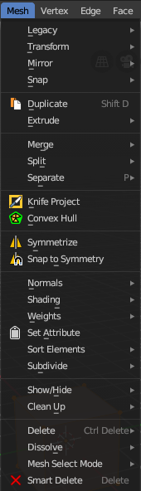
The Mesh Menu in Edit Mode contains the tools to manipulate the mesh geometry in Edit mode. It just exists for Mesh Objects.

Lots of functionality that could also belong here can also be found in the Tool Shelf. The difference is that the tools in the tool shelf are easier to access. And so it contains the most used tools for the daily work. While the Mesh menu contains the not so often used tools. Or tools where you use the hotkey anyway. Delete for example.

Legacy

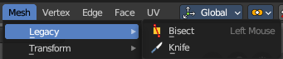
The legacy sub menu contains tools that exists in the tool shelf already. It's the old way to do things. Different to the tools in the tool shelf, these tools are usually modal. And performs once. You have to call them again in case you want to repeat the tool.

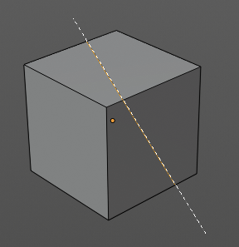
Bisect
Bisect cuts geometry along a plane. This description is a bit misleading though. You simply cut through the whole geometry by defining a line. And the cut goes through the geometry from the current view.

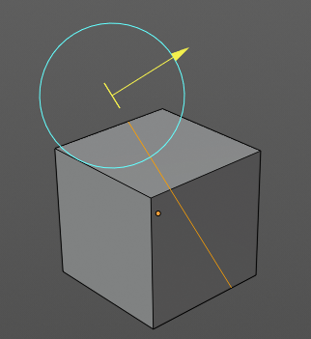
When you have set your cut and release the mouse then you reveal a widget with which you can move and rotate the cut. Clicking at the arrow and drag moves the cut. Clicking at the circle and drag rotates the cut.

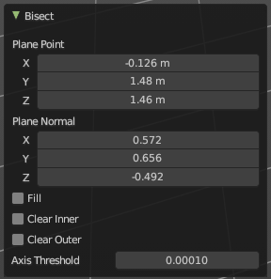
Last Operator Bisect

Plane Point X , Y , Z
Defines the start point of the Bisect cut.

Plane Normal X , Y , Z
The direction in which the bisect points.

Fill
Fills the cut.

Clear Inner
Removes the inner part of the face to cut.

Clear Outer
Removes the outer part of the face to cut.

Axis threshold
Axis threshold.

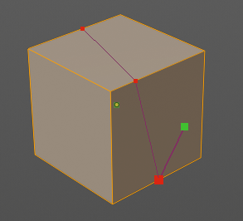
Knife tool
The Knife tool cuts the geometry, and adds edges. When it crosses existing geometry then it adds a vertice at the crossing point.
Usage: activate the tool, left click to define the starting point. This can also be a point in the middle of a face. But ideally you choose an existing vertice or an edge as the start and endpoints. The knife tool tries to snap to them when you get close with the mouse cursor.
When done press Enter or Spacebar to confirm. Right click abandons the operation.
When you create a vertice in the middle of a face, then the knife tool will try to connect this vertice by an existing vertice of this face when you confirm with spacebar.

Hotkey functionality in the footer text
Have a look at the footer when you work with this tool. Here you will find further instructions and hotkeys.
Enter, Pad Enter, Spacebar - confirm
Esc key, RMB - cancel the operation
LMB start the cut
Double LMB - close the cut
E - create new cut
Ctrl or Shift while dragging - Snap to the middle of an edge
Z - cut through the whole geometry, also the backfaces.
MMB - pan the view.
Alt MMB - rotate the view.

Transform

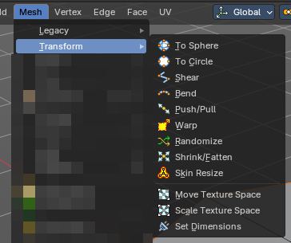

To Sphere
Shapes a selection of objects into the shape of a sphere. The calculation happens with the object origins.
In Object mode this tools requires to have more than one object selected.

Usage

Select the vertices, activate the tool, then drag the mouse in the 3D viewport. In the header you will read the current factor then. Which tells you how close you are towards the sphere shape.


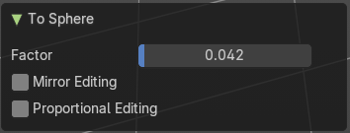
Last Operator To Sphere

Factor
The factor to transform the selection into a shape form.

Mirror Editing
Enable mirror editing.

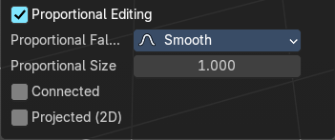
Proportional editing
Enables proportional editing. Activating proportional editing reveals further settings.

Proportional Falloff
Adjust the falloff methods.

Proportional Size
See and adjust the falloff radius.

Connected
The proportional falloff gets calculated for connected parts only.

Projected(2D)
The proportional falloff gets calculated in the screen space. Depth doesn't play a role. When it's in the radius, then it gets calculated.

To Circle
Transforms selected vertices into a circular arrangement.
Useful for reshaping loops, aligning geometry, or creating radial structures with precision.

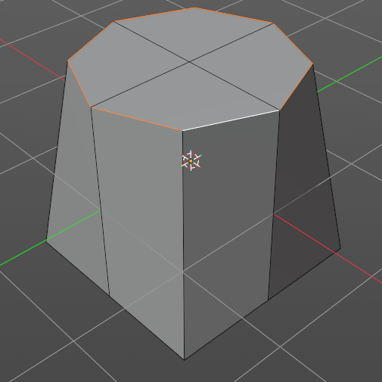
Usage
Select the loop of mesh geometry, activate the tool. In the Last Operator panel, you can then adjust properties after the operation.

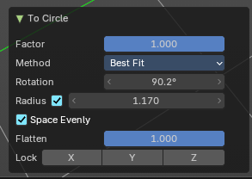
Last Operator To Sphere

Factor
Controls the strength of the circular transformation.
– 1.000: full circle.
– < 1.000: partial influence, blending with original shape.

Method
Defines how the circle is calculated:
– Best Fit: fits a circle to the selection using least-squares approximation.
– Interior Fit: Moves vertices inward toward the center of the selection.

Rotation
Applies a rotational offset to the resulting circle.

Radius
Sets a fixed radius for the circle.

Space Evenly
Distributes vertices evenly along the circle’s perimeter.
– Enabled: uniform spacing.
– Disabled: preserves original spacing.

Flatten
Controls how much the selection is flattened onto a plane before circularization.
– 1.000: full flattening.
– 0.000: preserves original depth variation.

Lock Axis (X, Y, Z)
Constrains transformation to specific axes. Useful for maintaining symmetry or aligning with existing geometry.

Shear
Shear shears the selection.
In Object mode this tools requires to have more than one object selected.
The shear tool works along a imaginary 2d plane. The shear axis controls if the items are sheared along the x or the y axes of this plane. This is the plane along which the transformation happens. You can shear along the x or the y axis of this plane.
To make things even more complicated, the orientation of this imaginary plane is defined by the Axis and Axis Ortho items below.

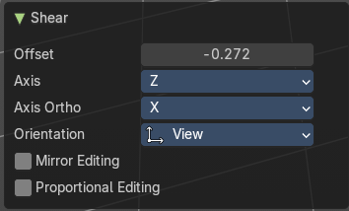
Last Operator Shear

Offset
Adjust an offset.

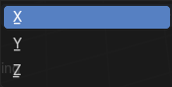
Axis
Defines one axis of the imaginary shear axis plane.

Axis Ortho
Defines the other axis of the imaginary shear axis plane.

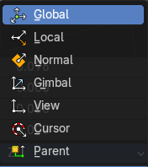
Orientation
Choose the orientation for the shear action.

Mirror Editing
Enable mirror editing.

Proportional editing
Enables proportional editing. Activating proportional editing reveals further settings.

Proportional Falloff
Adjust the falloff methods.

Proportional Size
See and adjust the falloff radius.

Connected
The proportional falloff gets calculated for connected parts only.

Projected(2D)
The proportional falloff gets calculated in the screen space. Depth doesn't play a role. When it's in the radius, then it gets calculated.

Bend
Bends the selection.

Push/Pull
It pushes or pulls the object positions relative to the center of the selection.
In Object mode this tool requires to have more than one object selected.

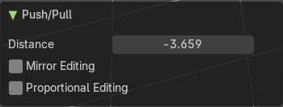
Last Operator Push/Pull

Distance
Adjust the distance of influence of the tool.

Mirror Editing
Enable mirror editing.

Proportional editing
Enables proportional editing. Activating proportional editing reveals further settings.

Proportional Falloff
Adjust the falloff methods.

Proportional Size
See and adjust the falloff radius.

Connected
The proportional falloff gets calculated for connected parts only.

Projected(2D)
The proportional falloff gets calculated in the screen space. Depth doesn't play a role. When it's in the radius, then it gets calculated.


Warp
Warps a mesh selection between two defined points.

Last operator Warp

Warp Angle
The strength of the warp effect

Offset Angle
An offset angle to bend side wards.


Min
The start point.

Max
The end point.

Randomize
This tool allows randomizes the positions of the selected vertices.


Last Operator Randomize

Amount
Adjust the amount.

Uniform
The uniform offset distance.

Normal
Align the offset direction to the normals.

Random Seed
The seed value for randomization.

Shrink/Fatten
Shrink/Fatten scales the selected geometry along its normals. Transform orientation and Pivot point gets ignored.
A positive value pushes the vertices outwards. A negative value pushes the vertices inwards.

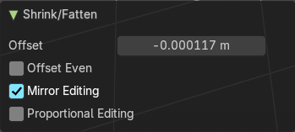
Last Operator Shrink/Fatten
The Last Operator Shrink/Fatten panel gives you tools to adjust the Shrink/Fatten operation. Here you have numeric input for the strength and a few more options.

Offset
Offset is the strength of the offset for Shrink/Fatten.

Offset Even
Offset Even scales the selection to give more thickness in even areas.

Mirror Editing
Enable mirror editing.

Proportional editing
Enables proportional editing. Activating proportional editing reveals further settings.

Proportional Falloff
Adjust the falloff methods.

Proportional Size
See and adjust the falloff radius.

Connected
The proportional falloff gets calculated for connected parts only.

Projected(2D)
The proportional falloff gets calculated in the screen space. Depth doesn't play a role. When it's in the radius, then it gets calculated.

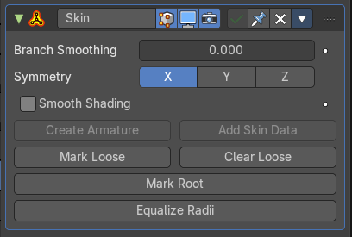
Skin Resize
This tool requires to have a skin modifier at the mesh. It scales the thickness of the skin.
While the operation you will see in the header the strength value for the skin.
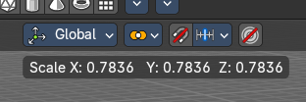

Last Operator Skin Resize

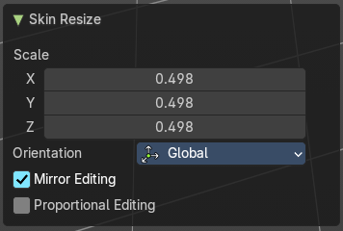
Vector
Adjust the position values for the three values.

Scale X, Y, Z
Limit the position relative to the source object.


Orientation
Orientation is a drop-down box choose the type of orientation for the mirroring action.

Mirror Editing
Enable mirror editing.

Proportional editing
Enables proportional editing. Activating proportional editing reveals further settings.

Proportional Falloff
Adjust the falloff methods.

Proportional Size
See and adjust the falloff radius.

Connected
The proportional falloff gets calculated for connected parts only.

Projected(2D)
The proportional falloff gets calculated in the screen space. Depth doesn't play a role. When it's in the radius, then it gets calculated.


Move Texture Space
This tool relies at the move tool. With the difference that it moves the texture space instead of the object. It has also a very special use case, and just works with a material with a Texture Coordinate / Generated node. And requires to have the shading at Material or Rendered to see a result in the viewport.
In the viewport you will see the UV cage in black color. In the header you will see the values for the current position of the UV cage.
Note that once done and applied, there is no way to reset the UV cage back to zero. When you repeat the operation, then the values will start at 0 again. Even when the UV cage is already offset.


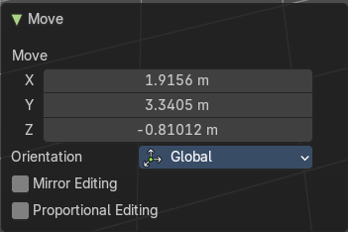
Last Operator Move

Move
Adjust in which directions you want to transform.

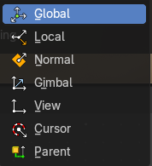
Orientation
Choose the orientation.

Mirror Editing
Enable mirror editing.

Proportional editing
Enables proportional editing. Activating proportional editing reveals further settings.

Proportional Falloff
Adjust the falloff methods.

Proportional Size
See and adjust the falloff radius.

Connected
The proportional falloff gets calculated for connected parts only.

Projected(2D)
The proportional falloff gets calculated in the screen space. Depth doesn't play a role. When it's in the radius, then it gets calculated.


Scale Texture Space
Scale Texture space is similar to the Move texture Space. With the only difference that it scales the UV space instead of moving it.
This tool relies at the scale tool. With the difference that it scales the texture space instead of the object. It has also a very special use case, and just works with a material with a Texture Coordinate / Generated node. And requires to have the shading at Material or Rendered to see a result in the viewport.
In the viewport you will see the UV cage in black color. In the header you will see the values for the current position of the UV cage.
Note that once done and applied, there is no way to reset the UV cage back to zero. When you repeat the operation, then the values will start at 0 again. Even when the UV cage is already offset.


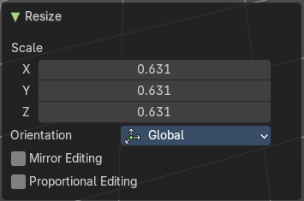
Last Operator Resize

Scale
Adjust in which directions you want to transform.

Orientation
Choose the orientation.

Mirror Editing
Enable mirror editing.

Proportional editing
Enables proportional editing. Activating proportional editing reveals further settings.

Proportional Falloff
Adjust the falloff methods.

Proportional Size
See and adjust the falloff radius.

Connected
The proportional falloff gets calculated for connected parts only.

Projected(2D)
The proportional falloff gets calculated in the screen space. Depth doesn't play a role. When it's in the radius, then it gets calculated.


Set Dimensions
Edit Mode Only!
Normally all scale operations in Bforartists are relative to the current selection and dimensions. And you always start with a relative value of 1.
Set dimensions allows to scale mesh selections in absolute world values. No matter how the initial values are. The new values gets set in the Last Operator.
Set dimensions is an add-on. You can turn it off in the add-ons section of the user preferences when you want.

Last Operator Set Dimensions


New Dimensions
When you activate the tool then you will see the world coordinates of the selection. Change the values to other world coordinates.

Mirror


Mirror mirrors the selected geometry along the defined axis.

Interactive Mirror
Mirror by hotkeys. You activate the tool, type in x for x global for example, or x x for x local. And the selection gets mirrored

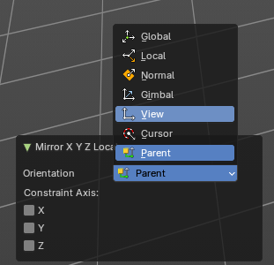
X Global, Y Global etc.
Mirrors the selection around the chosen axis.

Last Operator Mirror
The Last Operator Mirror panel gives you tools to adjust the mirror action.

Orientation
Orientation is a drop-down box choose the type of orientation for the mirroring action.

Constraint Axis
Constraint Axis gives you again the possibility to define the mirror axis. You can choose more than one axis here.

Mirror Vertex Group
This tool requires to have a vertex group assigned. It mirrors the selected vertex group.
This tool works only with a perfectly symmetrical mesh along the local X axis. Vertices that have no corresponding vertex on the other side will not be affected.

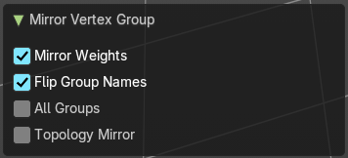
Last Operator Mirror Vertex Group

Mirror Weights
Mirrors the Weight Painting informations from the symmetrical counterpart. When both are selected it will become a group and weight information exchange. If only one is selected, then the information from the unselected vertice will go to the selected vertice.

Flip Group Names
Flip selected group names. This works with vertex groups with symmetrical name conventions. Like .L , .R, right, left.

All Groups
Pass information to all groups instead of the active one.

Topology Mirror
Use topology based mirroring.

Snap

Choose several methods to snap one element to another. The menu items should be self explaining.

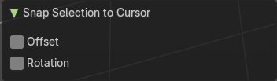
Last operator Snap Selection to Cursor

Offset
Keep the offset of the selected objects to each other.

Rotation
Rotate the selection to match cursor.

Single Operators

Duplicate
Duplicates the current selection.
When you duplicate a selection, then it sticks to the mouse until you left click. And moves around. A right click repositions the duplicated geometry at its original location.

Last Operator Duplicate

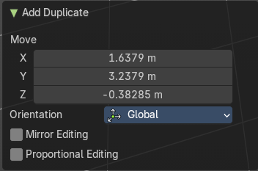
Mode
Not to find out. No tool tip, no entry in the Blender manual. Good Job Blender Developers.

Move X, Y, Z
Adjust the position.

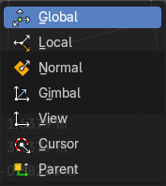
Orientation
Orientation is a drop-down box choose the type of orientation for the mirroring action.

Mirror Editing
Enable Mirror Editing.

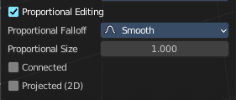
Proportional editing
Enables proportional editing. Activating proportional editing reveals further settings.

Proportional Falloff
Adjust the falloff methods.

Proportional Size
See and adjust the falloff radius.

Connected
The proportional falloff gets calculated for connected parts only.

Projected(2D)
The proportional falloff gets calculated in the screen space. Depth doesn't play a role. When it's in the radius, then it gets calculated.

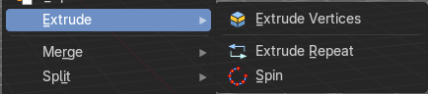
Extrude
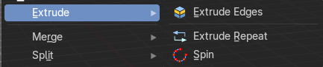
Extrude is a sub menu with several extrude methods. The contend is dependent of the mesh select mode.

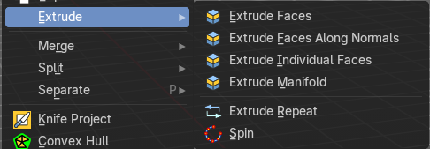

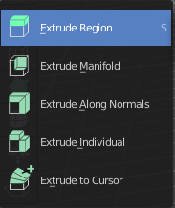
Note that the tool shelf also contains extrude functionality. And a few methods here are a double. These are marked as legacy here in the manual.

Extrude Vertices
Extrudes out the selected vertices by moving the mouse.

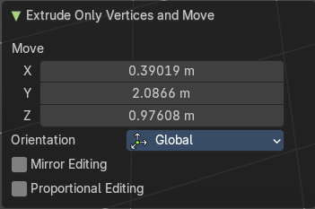
Last Operator Extrude Only Vertices and Move

Move X Y Z
The coordinates for the extruded geometry.

Orientation
Choose the type of orientation, in which coordinate system the action should happen.

Mirror Editing
Enable Mirror Editing.

Proportional editing
Enables proportional editing. Activating proportional editing reveals further settings.

Proportional Falloff
Adjust the falloff methods.

Proportional Size
See and adjust the falloff radius.

Connected
The proportional falloff gets calculated for connected parts only.

Projected(2D)
The proportional falloff gets calculated in the screen space. Depth doesn't play a role. When it's in the radius, then it gets calculated.

Extrude Edges
Extrudes out the selected edges by moving the mouse.

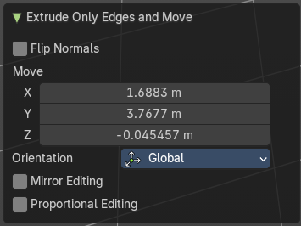
Last Operator Extrude Only Edges and Move

Flip Normals
Flip the normals at the involved faces.

Move X Y Z
The coordinates for the extruded geometry.

Orientation
Choose the type of orientation, in which coordinate system the action should happen.

Mirror Editing
Enable Mirror Editing.

Proportional editing
Enables proportional editing. Activating proportional editing reveals further settings.

Proportional Falloff
Adjust the falloff methods.

Proportional Size
See and adjust the falloff radius.

Connected
The proportional falloff gets calculated for connected parts only.

Projected(2D)
The proportional falloff gets calculated in the screen space. Depth doesn't play a role. When it's in the radius, then it gets calculated.

Extrude Faces (Legacy)
Extrude the selected faces along their normals. This functionality is part of the Extrude Region tool in the tool shelf.

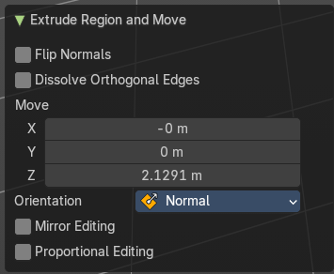
Last Operator Extrude Region and Move

Flip Normals
Flips the normals of the extruded faces.

Dissolve Orthogonal Edges
Dissolves orthogonal edges at extrusion.

Move X, Y Z
The position. Attention, the actual world orientation and rotation does not matter here. It always starts with a value of zero, and moves relative to this zero then. For the actual location values have a look in the sidebar in the transform panel.

Orientation
The extrusion can have different orientations. The menu items should be self explaining.

Mirror Editing
Enable Mirror Editing.

Proportional editing
Enables proportional editing. Activating proportional editing reveals further settings.

Proportional Falloff
Adjust the falloff methods.

Proportional Size
See and adjust the falloff radius.

Connected
The proportional falloff gets calculated for connected parts only.

Projected(2D)
The proportional falloff gets calculated in the screen space. Depth doesn't play a role. When it's in the radius, then it gets calculated.

Extrude Faces along Normals (Legacy)
In the toolshelf it's the Extrude Along Normals tool. Extrudes the selection along local normals. You won't see a widget here. Simply drag.
The method works the same in all Mesh select modes. Vertice, Edge and Face Mode.

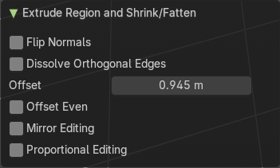
Last Operator Extrude Region and Shrink/Fatten

Flip Normals
Flips the normals of the extruded faces.

Dissolve Orthogonal Edges
Dissolves orthogonal edges at extrusion.

Offset
The current extrude amount.

Offset Even
Scales the offset to give more even thickness. Without this checked the farer away faces will have a bigger extrude amount.

Mirror Editing
Enable Mirror Editing.

Proportional editing
Enables proportional editing. Activating proportional editing reveals further settings.

Proportional Falloff
Adjust the falloff methods.

Proportional Size
See and adjust the falloff radius.

Connected
The proportional falloff gets calculated for connected parts only.

Projected(2D)
The proportional falloff gets calculated in the screen space. Depth doesn't play a role. When it's in the radius, then it gets calculated.

Extrude Individual Faces ( Legacy)
In the tool shelf the tool is called Extrude Individual. Extrudes the selection along local normals of each individual face. You won't see a widget here. Simply drag.
The method works the same in all Mesh select modes. Vertice, Edge and Face Mode.

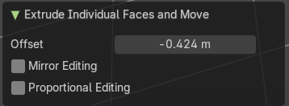
Last Operator Extrude Individual Faces and Move

Offset
The current extrude amount.

Mirror Editing
Enable Mirror Editing.

Proportional editing
Enables proportional editing. Activating proportional editing reveals further settings.

Proportional Falloff
Adjust the falloff methods.

Proportional Size
See and adjust the falloff radius.

Connected
The proportional falloff gets calculated for connected parts only.

Projected(2D)
The proportional falloff gets calculated in the screen space. Depth doesn't play a role. When it's in the radius, then it gets calculated.

Extrude Manifold (Legacy)
The same tool exists in the tool shelf. Extrude, dissolve Edges whose faces form a flat surface, and intersect new edges.
The method works the same in all Mesh select modes. Vertice, Edge and Face Mode.

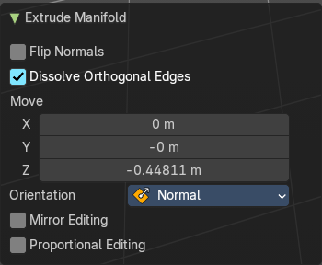
Last Operator Extrude Manifold

Flip Normals
Flips the normals of the extruded faces.

Dissolve Orthogonal Edges
Dissolve edges that are at the same straight surface.

Move X, Y Z
The position. Attention, the actual world orientation and rotation does not matter here. It always starts with a value of zero, and moves relative to this zero then. For the actual location values have a look in the sidebar in the transform panel.

Orientation
The widget can have different orientations. The menu items should be self explaining.

Mirror Editing
Enable Mirror Editing.

Proportional editing
Enables proportional editing. Activating proportional editing reveals further settings.

Proportional Falloff
Adjust the falloff methods.

Proportional Size
See and adjust the falloff radius.

Connected
The proportional falloff gets calculated for connected parts only.

Projected(2D)
The proportional falloff gets calculated in the screen space. Depth doesn't play a role. When it's in the radius, then it gets calculated.

Extrude Repeat
All modes. Extrudes into the Z depth of the viewport, and repeats the extrusion by the adjusted amount. You have to adjust the extrusion afterwards.

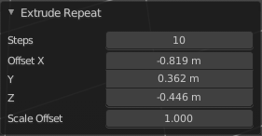
Last Operator Extrude Repeat

Steps
How much repetitions.
Offset X / Y / Z
The offset in the x y and z direction.
Scale Offset
The scale factor of the extruded element.

Spin
All modes. Extrudes in a curve form.

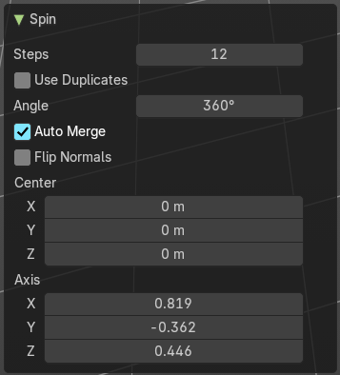
Last Operator Spin

Steps
How much segments.

Use Duplicates
Creates not connected geometry. In Vertex mode single vertices for example. Auto Merge and Flip Normals will not be available with duplicates.

Angle
The angle to extrude.

Auto Merge
Merge first and last element when the extrude is a full circle.

Flip Normals
Flip the normals of the extruded geometry.

Center X / Y / Z
The center point of the spin circle.

Axis
Axis in global View space. The values goes from -1 to 1.

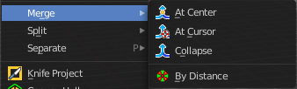
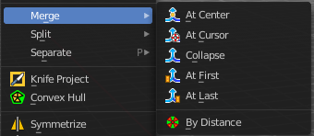
Merge
Merges the geometry.

At Center, At Cursor, Collapse, At First, At Last
Merges the geometry with the given methods.
The methods At First and At Last just shows when you have vertices selected, and there is at least one first vertice and one last vertice to merge at. So minimum two. But you can have more than one vertices selected.

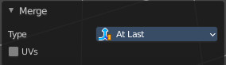
Last Operator Merge

Type
Choose the merge method again.

UV's
Move the UV's according to the merge.

By Distance
Merge the vertices by their distance to each other. This tool is meant to remove double vertices at the same location.

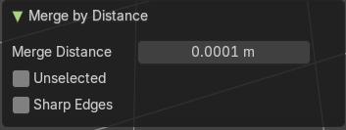
Last Operator Merge by Distance

Merge Distance
Adjust the distance below which the vertices gets merged.
Merge selected vertices to unselected vertices.

Unselected
Merge unselected geometry.

Sharp Edges
Calculate sharp edges using available normal custom data.

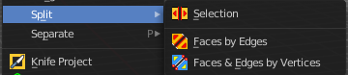
Split

Selection
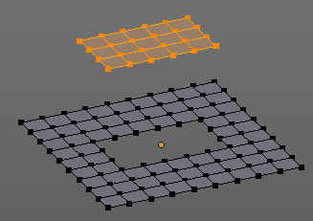
Split splits the edges between the selected vertices. It creates two edges out of one. And splits the edge by that.
The mode doesn't matter. There will always the edges be splitted.

Faces by Edges / Faces by Edges by Vertices
Splits selected edges so that each neighbor face gets its own copy. You have two methods here.

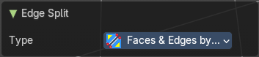
Last Operator Edge Split

Type
Choose the method again.

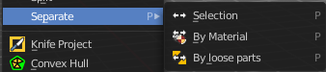
Separate
Separate separates the selected geometry, and creates a new object. The geometry becomes uneditable, since it is now a new object. You will have to leave the Edit mode, select the new object, and re-enter Edit mode when you want to edit it.

Selection
Selection separates the current selection.

By Material
By Material separates all geometry that has the same material than the current selection.

By Loose Parts
By Loose parts separates all geometry that is connected by edges to the current selection.

Knife Project
Knife Project uses an object as a knife to cut edges into a mesh.
Usage: Create a cube. Create a circle. Move the circle in front of the cube so that the geometry does not overlap the cube geometry. Enter Edit Mode with the cube. In the outliner hold down SHIFT, and select the circle. Note that you can select the circle in the 3d view with holding down CTRL.
Now that both objects are selected, go into front view, or whatever view you want. Just make sure that in the view the circle covers a part of the cube. Projection of the cut happens from the current view. Click the Knife Project tool.
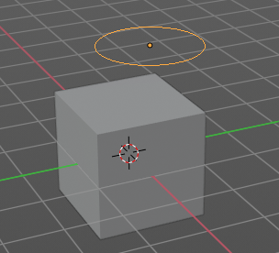 | 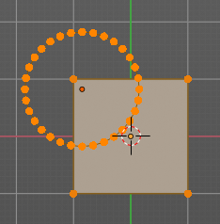 | 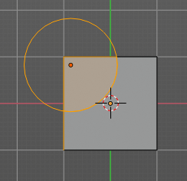 | 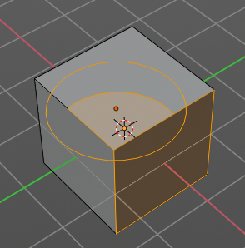

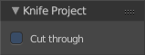
Last Operator Knife Project

Cut through
The cut goes through the whole object when the Cut through checkbox is ticked.
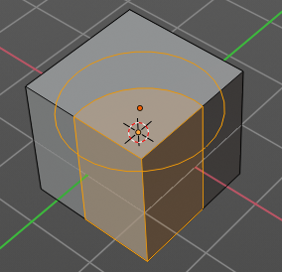

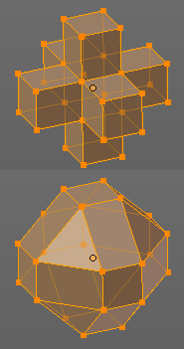
Convex Hull
Creates a convex hull around the outside of selected vertices. The old faces and inlaying vertices gets removed.

Last Operator Convex Hull

Delete Unused
Removes vertices that are not part of the convex geometry.

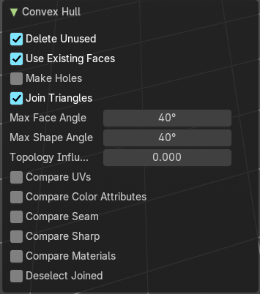
Use existing Faces
Use existing input faces that lies on the hull where possible. This option allows to have N-Gons in the convex hull.

Make Holes
Deletes edges and faces in the hull that were part of the input. This allows to delete faces between the existing mesh and the convex hull.

Join Triangles
Joins adjacent triangles into quads.

Max Face Angle
Max Face Angle belongs to the Join Triangles setting. Set the maximum face angle.

Max Shape Angle
Max Face Angle belongs to the Join Triangles setting. Set the maximum shape angle.

Topology influence
How much to priorize regular grids of quads as well as quads that touch existing quads.

Compare UV's
Takes existing UV patches for the calculation into account.

Compare Color Attributes
Takes existing color attributes for the calculation into account.

Compare Seam
Takes existing seams for the calculation into account.

Compare Sharp
Takes existing sharp edges for the calculation into account.

Compare Materials
Takes existing materials for the calculation into account.

Deselect joined
Only select remaining triangles that were not merged.

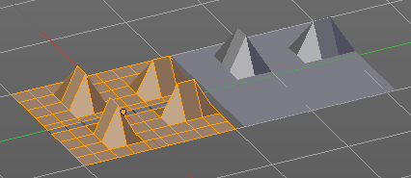
Symmetrize
The Symmetrize tool mirrors the selected geometry symmetrical along a world axis.

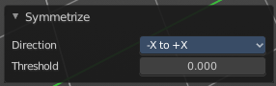
Last Operator Symmetrize

Direction
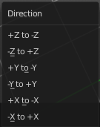
Direction is a drop down box define the mirroring direction.

Threshold
Adjust a distance after which the mirroring should happen, relative to the mirror axis. 0 means it mirrors the geometry directly at the axis.

Snap to Symmetry
Tries to snap the selected vertices symmetrical along the chosen world orientation.

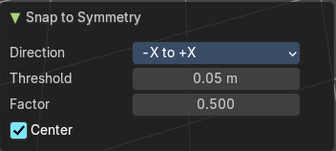
Last Operator Snap to Symmetry

Direction
The calculation direction.

Threshold
The threshold defines the radius in which matching vertices gets located. When you get a warning that snapping failed try increasing the threshold value.

Factor
The snapping factor. Blend mirrored locations from one side to the other. 0.5 is blending both sides equal.

Center
Snap vertices in the center axis to zero.

Normals

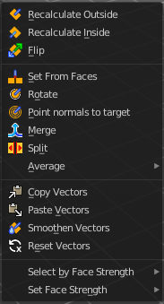
This menu contains functionality about dealing with normals. Normals influences the shading and the direction of a face. They can point inwards or outwards. And edges can be split. So that two adjacent faces have a sharp edge.
You can activate the display of normals in the Overlays panel in Edit mode.

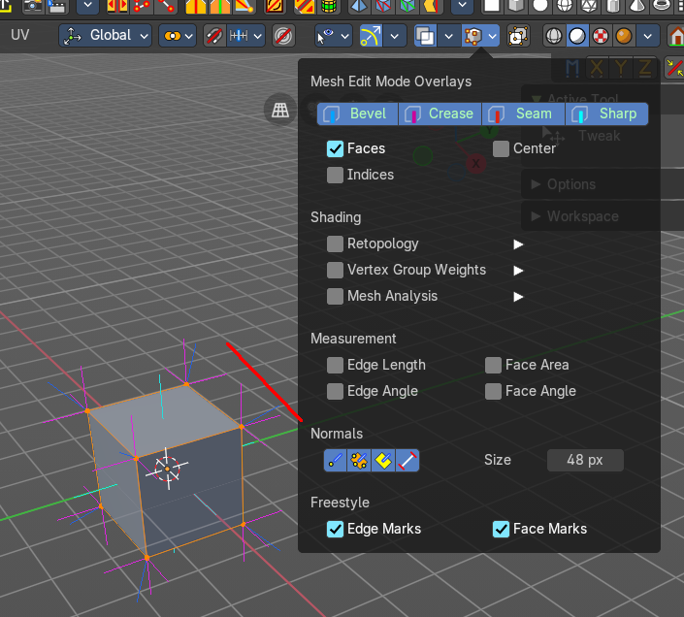

Recalculate Outside
Recalculates the normals of the selected geometry so that everything points outwards.

Recalculate Inside
Recalculates the normals of the selected geometry so that everything points inwards.

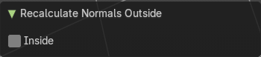
Last Operator Recalc Outside

Inside
Inside recalculates the normals of the selected geometry so that everything points inwards.

Flip
Flips the direction of the normals of the selected geometry.

Last Operator Flip Normals

Custom Normals only
Only flip the custom loop normals of the selected elements.

Set from Faces
Sets the vertex normals from the selected faces. This tool requires to have Auto smooth activated!

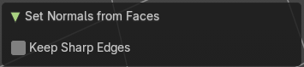
Last Operator Set Normals from Faces

Keep Sharp Edges
Don’t set sharp edges to faces.

Rotate
Rotate the normals of the selected vertices manually.

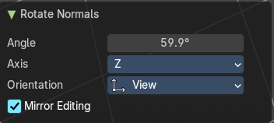
Last Operator Rotate Normals

Angle
The angle of the selected normal(s).

Axis
The axis to rotate around.

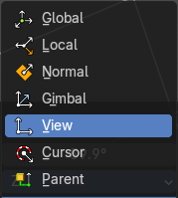
Orientation
Choose the type of orientation, in which coordinate system the action should happen.

Mirror Editing
Enable mirror editing.

Point Normals to Target
All vertex normals will point to a specific target. This target can be chosen from hotkeys. They show in the header.

Pressing R for Reset will reset the normals to where they were before the operation.

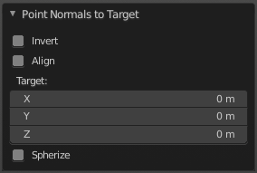
Last Operator Point Normals to Target

Invert
The normal directions are reversed from what is specified.

Align
All normals will point in the same direction.

Target
The target position.

Spherize
Each normal will be interpolated between its original value and the direction to the target.

Merge
Merge all of the normals at selected vertices, making one average normal for all of the faces.

Split
Split the normals at all selected vertices so that there are separate normals for each face, pointing in the same direction as those faces.

Average
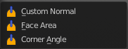
Average all of the normals in each fan of faces between sharp edges at a vertex.

Custom Normal
Take the average of vertices normals.

Face Area
Set all vertices normals by face area.

Corner Angle
Set all vertices by corner angle.

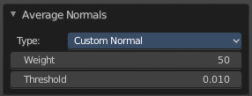
Last Operator Average Normals

Type
Choose the average type again.

Weigh
Just for custom normals method. Weight applied by face.

Threshold
Just for custom normals method. Threshold value for different weights to be considered as equal.

Copy Vectors
Copies the normals of a single selected vertice.

Paste Vectors
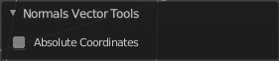
Pastes the normals from a formerly copied selected vertice to the currently selected vertice.

Last Operator Normals Vector Tools

Absolute Coordinates
When you paste normals then they get pasted relative to the current orientation of the selected vertice. With absolute coordinates the normals gets pasted in world coordinates.

Smooth Vectors
Smooth custom normals towards the adjacent vertex normals.

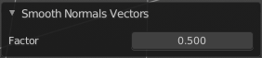
Last Operator Smooth Normals Vectors

Factor
Adjust how strong the smoothen should be.

Reset Vectors
Resets the normal of the selected element(s).

Select by Face Strength
Face strength gets used by the Weighted Normals modifier. See Face Influence checkbox.
Select faces with either weak or medium or strong face strength.

Set Face Strength
Face strength gets used by the Weighted Normals modifier. See Face Influence checkbox.
Set selected faces to either a weak, a medium or a strong face strength.

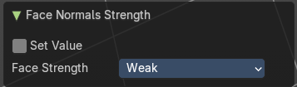
Last Operator Face Normal Strength

Set Value
Unticked it selects by face strength by weak, medium or high. Ticked it sets the face strength to weak, medium or high.

Face Strength
Resets the normal of the selected element(s).

Shading
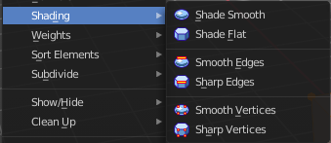
Sets the shading of the selected elements to either smooth or flat.

Shading is under the hood a normals operation.

Shade smooth
Display shading smooth.

Shade Flat
Display shading flat.

Smooth Edges
Clear as sharp marked edges and set them to smooth.

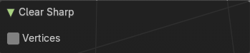
Last Operator Clear Sharp

Vertices
Consider vertices instead of edges to select which edges to set to smooth.

Sharp Edges
Mark selected edges as sharp.

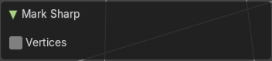
Last Operator Mark Sharp

Vertices
Consider vertices instead of edges to select which edges to set to sharp.

Smooth Vertices
Clear as sharp marked edges and set them to smooth. But the calculation happens from the selected vertices instead of the edges.

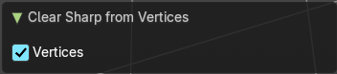
Last Operator Clear Sharp from Vertices

Vertices
Consider vertices instead of edges to select which edges to set to sharp.

Sharp Vertices
Mark selected edges as sharp. But the calculation happens from the selected vertices instead of the edges.

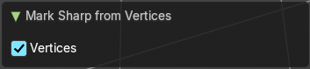
Last Operator Mark Sharp from Vertices

Vertices
Consider vertices instead of edges to select which edges to set to sharp.

Weights

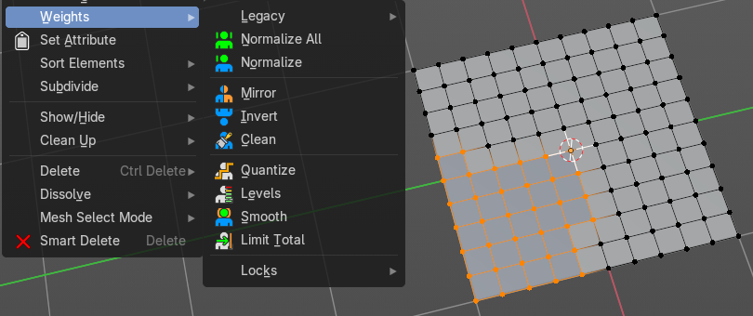
The Weights menu contains Weight tools. Those tools are meant to modify the weight mapping. At characters for example. The Weight Tools requires Vertex Groups to work with. Such Vertex groups gets created when you do weight painting at a character for example. Here is defined what bone is connected to what vertice.
In Edit Mode the weight mapping doesn't show. Here you work with the Vertex Groups.
In Weight paint mode the weight painting shows with colors. Here you usually paint the weighting.
This menu items also exists in Weight Paint mode.

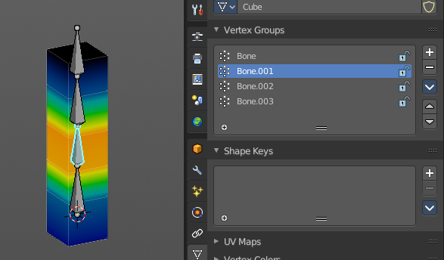
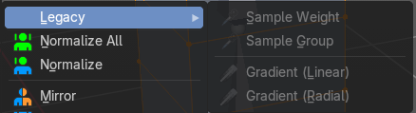
Legacy sub menu
Contains legacy menu items. They can currently not be activated.

Normalize All
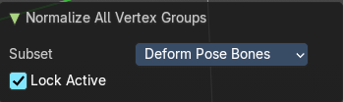
While weight painting it can happen that a vertice gets several weightings assigned. Normalize all normalizes the weight of all Vertex groups so that the values for the single vertices in the sum is 1.

Last Operator Normalize all

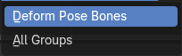
Subset
Subset is a drop-down menu choose the Subset method.

Lock Active
Keep the values of the active group while normalizing others.

Normalize
Normalize normalizes the weight of the current selected Vertex group so that the values for the single vertices in the sum is 1. Means when there is influence from other groups, then those values are kept, but the one for the current group gets lowered so that the sum is 1.
The Last Operator Normalize panel has no adjustable settings.

Mirror
Mirror Vertex Group mirrors Vertex Groups and flips weights and/or names. It only edits selected Vertices. It flips when both sides are selected. Otherwise it copies from Unselected.

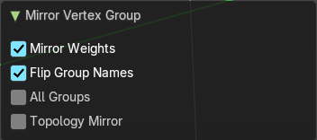
Last Operator Mirror Vertex Group

Mirror Weights
With Mirror Weights ticked it mirrors the weights.

Flip Group Names
With Flip Group Names ticked it flips the Group names.

All Groups
Mirrors all Vertex Groups

Topology Mirror
Uses topology based mirroring. This requires matching mirrored topology.

Invert
Invert inverts the weight painting for the selected vertex group.

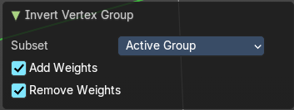
Last Operator Invert Vertex Group

Subset
Subset is a drop-down menu choose the Subset method.

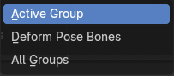
Add Weights
Add Vertices from Groups that have zero Weighting before inverting.

Remove Weights
Remove Vertices from Groups that have zero weight after inverting.

Clean
Removes Vertex group assignments that are not required from the active vertex group.

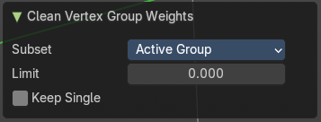
Last Operator Clean Vertex Group

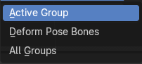
Subset
Subset is a drop-down menu choose the Subset method.

Limit
Remove weights that are below or equal to the limit value.

Keep Single
Keep Vertices assigned to at least one vertex group when cleaning.

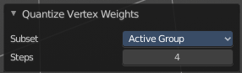
Quantize
Quantize quantizes the weight paint values. It starts with 4 steps. With a step of 1 you have a single vertex color, no matter how you have painted it before.

Last Operator Quantize

Subset
Subset is a drop-down menu choose the Subset method.

Steps
Here you adjust in how many steps the weight paint colors should be divided.

Levels
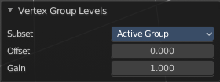
Adds some offset to the Weight paint, and multiplys it with some gain.

Last Operator Vertex Group Levels

Subset
Subset is a drop-down menu choose the Subset method.

Offset
Here you adjust the offset.

Gain
Here you adjust the gain.

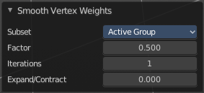
Smooth
Smooths the weight for selected vertices.

Last Operator Smooth Vertex Weights

Subset
Subset is a drop-down menu choose the Subset method.

Factor
Here you adjust the factor.

Iterations
Here you adjust how many iterations you use.

Expand/Contract
Expand or contract the weights.

Limit Total
Limit number of Weights per vertex. The lowest weights gets removed.
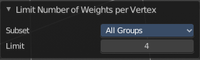
This is of interest when you have for example five bones associated with a vertice. But your game engine just allows four ...

Last Operator Limit Number of Weights per Vertex

Subset
Subset is a drop-down menu choose the Subset method.

Limit
Here you adjust how many weights are allowed.

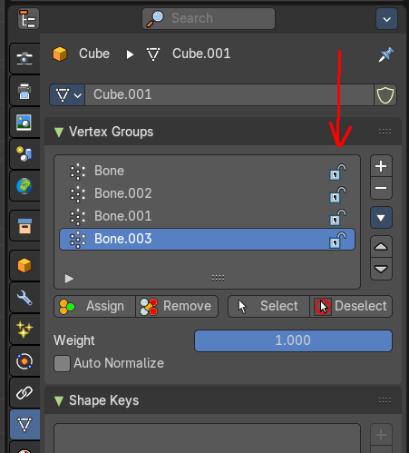
Locks
The locks from the Vertex groups as operators.

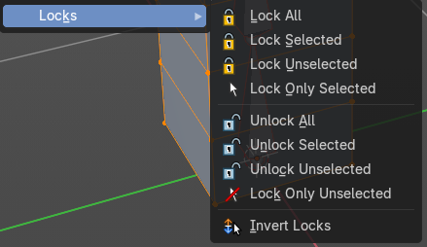

Set Attribute

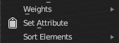
Set values of the active attribute for the selected element. It calls a popup where you can add an attribute. A vertex group index number or a uv map value for example. It depends of the element.

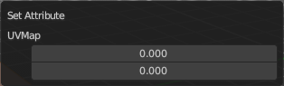
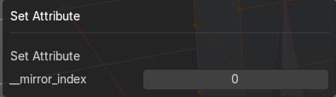

Sort Elements

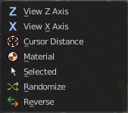
Sort Elements is a menu with different sorting methods. It allows you to reorder the mesh indices of the selected mesh elements by various methods.
The indices can be turned on in the Overlays menu.
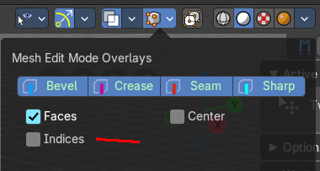
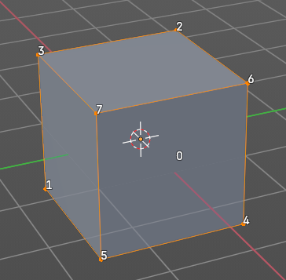

View Z Axis
Sorts along the active view’s Z axis, from farthest to nearest. You can use Reverse if you want it the other way.

View Y Axis
Sorts along the active view’s Y axis, from farthest to nearest. You can use Reverse if you want it the other way.

Cursor Distance
Sorts from nearest to farthest away from the 3D cursor position.

Material
Faces only! Sorts faces by their lowest material index up to highest material index. Order of faces inside each of those material groups remains unchanged.

Note that the Reverse option only reverses the order of the materials. And the order of the faces inside them.

Selected
Moves all selected elements to the beginning without affecting their relative orders. Attention, this option will also affect unselected element indices!

Randomize
Randomizes the indices of selected elements. This option does not affect the unselected elements.

Reverse
Reverses the order of the selected elements.

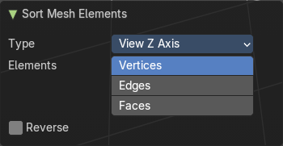
Last Operator Sort Mesh Elements
Sort Elements always brings up the same last operator. But with a small difference for Randomize and Reverse. Reverse has no checkbox. And Randomize has a Seed checkbox.

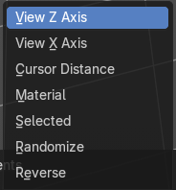
Type
This is a drop-down box choose the sort method again.

Vertices, Edges or Faces
Adjust if the sort will affect the vertices, edges or faces.

Reverse
Reverses the sorting.

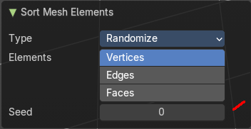
Seed Edit box (Randomize only)
The seed option allows you to get another randomization – the same seed over the same mesh/set of selected elements will always give the same result!

Subdivide
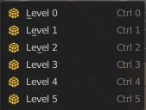
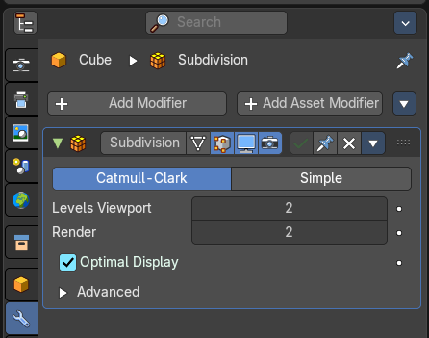
Subdivide is a menu where you can quickly add and change a subdivision surface modifier with a predefined resolution in a quick way. Especially when you use the hotkey for it. The subdivision surface modifier panel can then as usual be found in the Properties editor in the Modifier tab.

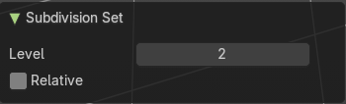
Last Operator Subdivision Set

Level
Set the level of subdivisions

Relative
Applies the sub surf level as an offset to the already existing sub surf level.

Show / Hide

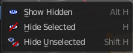
The Show/Hide menu is available for all object types and in all modes. It is usually in the object related menu to find. In Object mode it's the Object menu, for a curve object in edit mode it is the Curve menu. It always contains three menu items. Show Hidden, Hide Selected and Hide Unselected.

Show Hidden
Makes all hidden elements in the scene visible again.

Hide Selected
Hides the selected elements.

Hide Unselected
Hides the not selected elements. The selected elements stays visible.

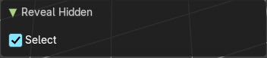
Last Operator Reveal Hidden / Hide Selected

Select
Define if the selected or the unselected elements gets hidden or revealed.

Cleanup

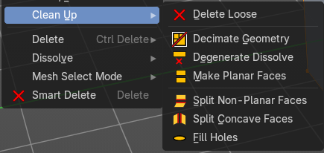
In the Cleanup menu you will find tools to clean up the current geometry.

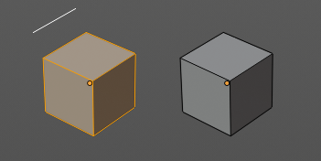
Delete Loose
Delete loose deletes not connected geometry. Vertices, Edges, and Faces. The tool starts with deleting Vertices and Edges. But you can tick Faces in the Last Operator too, and then it also removes not connected Faces.

Last Operator Delete Loose

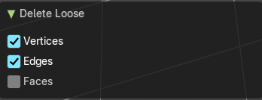
Vertices
Delete Vertices.

Edges
Delete Edges.

Faces
Delete Faces.

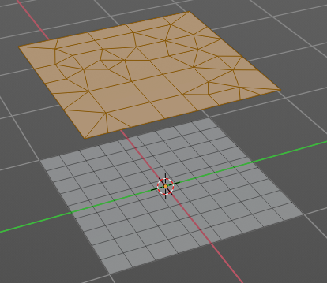
Decimate Geometry
Decimate Geometry decimates the currently selected geometry. It starts with a Ratio of 1. Which means no decimation. The lower the ratio the more decimation you will get. The Decimate Modifier works with Tris!

Last Operator Decimate Geometry

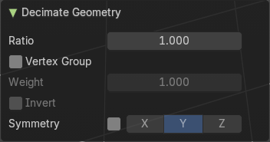
Ratio
Adjust the strength of decimation.

Vertex Group
Use active Vertex Group as an influence. You need to have a Vertex Group.

Weight
Adjust the Vertex Group Strength.

Invert
Invert Vertex Group Influence.

Symmetry
Make the decimation geometry symmetric along a chosen world axis.

Degenerate Dissolve
Removes zero size Faces and Edges.

Last Operator Degenerate Dissolve

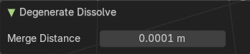
Merge Distance
Maximum distance between elements to merge.

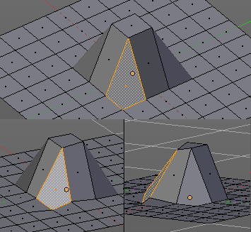
Make Planar Faces
Make Planar Faces tries to make the selected faces planar. Quads or N-Gons for example can have vertices that are not planar.

Last Operator Make Planar Faces

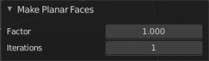
Factor
Here you adjust how strong the influence should be.

Iterations
Here you adjust how often it should repeat in the try to find a solution.

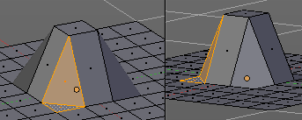
Split Non-Planar Faces
Split Non Planar Faces splits up non planar Quads and N-Gons to end in planar faces.

Last Operator Split Non-Planar Faces

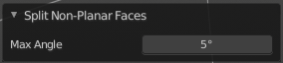
Max Angle
Limit the action to a maximum angle.

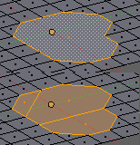
Split Concave Faces
Splits concave faces to make the geometry more stable. This tool is thought for N-Gons.

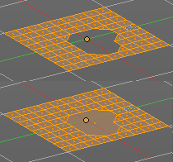
Fill Holes
Fill holes closes holes in the mesh geometry.
Fill holes can just calculate one face size at one time. So when you have several holes in the mesh, let's say one is a tri, and one is a quad, then you need to calculate twice.

Last Operator Fill Holes

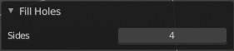
Sides
Define what face size will be filled.

Delete

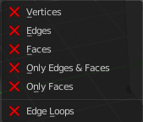
The smart delete add-on. usually does the delete job already fine. It deletes the selected element(s).
There are sometimes some situations where you need more control over what you want to delete. The tools for this can be found in the Delete menu.

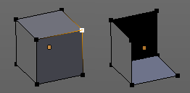
Vertices
Deletes the selected vertices, and all with it connected edges and faces.

Edges
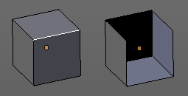
Deletes the selected edges and the connected faces.

Faces
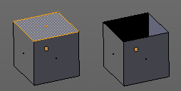
This one works similar to the smart delete. It deletes the selected faces.

Only Edges and Faces
This mode is of interest when you have more than one selection mode activated. It deletes then just the selected edges and faces. And not single vertices.

Only Faces
This mode is of interest when you have more than one selection mode activated. Just selected faces gets deleted. Not single edges or vertices.

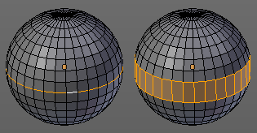
Edge Loops
This method works similar to the smart delete tool. It deletes the edge loop. But it selects the faces of the edge ring. And the Last operator offers you the option to split off face corners.

Last Operator Delete Edge Loop

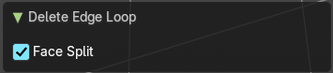
Face Split
Split off face corners to maintain surrounding geometry.

Dissolve
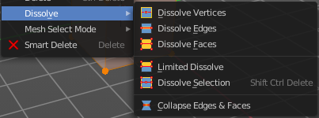
Dissolve operations removes for examples selected vertices, edges and faces. But they are not delete operations. They are union tools.
When you for example choose Delete vertices from the mesh menu, then the involved faces can get deleted too. When you choose Dissolve vertices, then the vertices gets removed, and the faces stays intact. The edges gets unioned.
Dissolve is a union operation.

Dissolve Vertices
Dissolve Vertices dissolves the selected Vertices.
Note that pressing DEL in Vertice select mode calls Dissolve Vertices already. It's the same operator. But you don't get the Last operator that way.

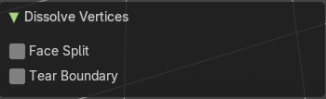
Last Operator Dissolve Vertices

Face Split
Split off Face corners to maintain surrounding geometry

Tear Boundary
Split off Face corners instead of merging faces.

Dissolve Edges
Dissolve Edges dissolves the selected Edges.
Note that pressing DEL in Edge select mode calls Dissolve Edges already. It's the same operator. But you don't get the Last operator that way.

Last Operator Dissolve Edges

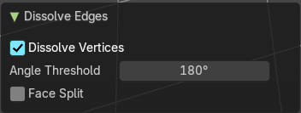
Dissolve Vertices
When the dissolve operation leaves vertices behind, then this vertices will be dissolved too.

Angle Threshold
Remaining vertices which eseparate edge pairs are preseved if their edge angle exceeds this threshold

Face Split
Split off Face corners to maintain surrounding geometry.

Dissolve Faces
Dissolve Faces removes the inlaying edges of the selected faces. This faces becomes one big N-Gon.

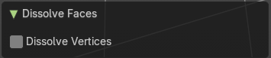
Last Operator Dissolve Faces

Dissolve Vertices
When the dissolve operation leaves vertices behind, then this vertices will be dissolved too.

Limited Dissolve
Dissolve selected edges and vertices, limited by the surrounded angles.

Last Operator Limited Dissolve

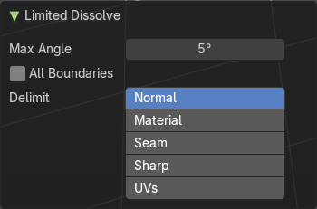
Max Angle
The angle limit up to which the dissolve happens.

All Boundaries
Dissolve all vertices in between face boundaries.

Delimit
By which element to delimit.

Dissolve Selection
Dissolves the selected geometry.

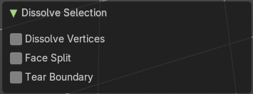
Last Operator Dissolve Selection

Dissolve Verts
When the dissolve operation leaves vertices behind, then this vertices will be dissolved too.

Face Split
Split off Face corners to maintain surrounding geometry.

Tear Boundary
Split off face corners instead of merging faces.

Collapse Edges & Faces
Collapses the selected edges or faces to a vertice at the center of the selection.

Mesh Select Mode

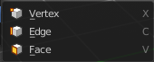
Mesh Select mode is a sub menu Set the current mesh select mode. Its functionality is equal to the mesh select mode buttons in the header. Just that you can't select more than one mode directly here.
This menu just exists to show and to edit the hotkeys. Not to work with it.

Smart Delete

Smart Delete
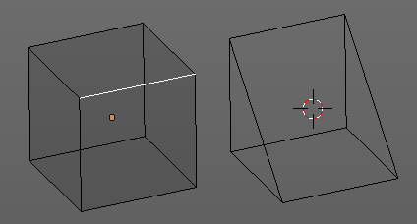
Smart delete deletes what is selected in an intelligent way. When you for example delete an edge then the edge gets deleted. But it also deletes the vertices connected to this edge. It performs a Dissolve operation under the hood.
There is also a Delete and Dissolve menu in the Mesh menu, choose different methods for deleting if required.
Smart delete is an add-on. And can be deactivated if desired.

